“Denying Writes to Executables”
A Project Report Submitted in the partial fulfillment of the requirements for the award of the degree of
BACHELOR OF TECHNOLOGY
In
DEPARTMENT OF COMPUTER SCIENCE ENGINEERING
Course: Operating Systems and Systems Programming
By
2520030396- mokshitha
2520030047-chandrika
2520030287- hasini
Team No. 15 | Section 6
Under the Esteemed Guidance of
Professor
Department of Computer Science and Engineering


Academic Year 2026–2027

K L (Deemed to be) University
DEPARTMENT OF COMPUTER SCIENCE ENGINEERING
&
DEPARTMENT OF COMPUTER SCIENCE AND INFORMATION TECHNOLOGY
Declaration
The Project Report entitled “Denying Writes to Executables” is a record of Bonafide work of Monisha Raghini Chelle - 2520030537, Parvathaneni Jaahnavi - 2520030441, and Shaik Juneeth - 2520030435 submitted in partial fulfillment for the award of B. Tech in Computer Science and Engineering to the K L (Deemed to be) University. The results embodied in this report have not been copied from any other department/University/Institute.
2520030396- mokshitha
2520030047-chandrika
2520030287- hasini

K L (Deemed to be) University
DEPARTMENT OF COMPUTER SCIENCE ENGINEERING
CERTIFICATE
This is certify that the mini project based report entitled “Denying Writes to Executables” is a bonafide work done and submitted by Monisha Raghini Chelle – 2520030537, Parvathaneni Jaahnavi – 2520030441, and Shaik Juneeth – 2520030435, in partial fulfillment of the requirements for the award of the degree of BACHELOR OF TECHNOLOGY in Department of Computer Science Engineering, K L (Deemed to be) University, during the academic year 2026–2027.
Signature of the Guide
Signature of the Course Coordinator Signature of the HOD
[Course Coordinator Name]
[HOD Name]

ACKNOWLEDGEMENT
The success in this project would not have been possible without the timely help and guidance rendered by many people. We express our sincere thanks to all those who assisted us directly or indirectly in the completion of this project.
Our greatest appreciation goes to our guide, Ravindra Gaddam, Professor, Department of Computer Science and Engineering, for the support, encouragement, and technical guidance provided throughout the project.
We express our gratitude to the Course Coordinator and the Head of the Department of Computer Science and Engineering for providing the academic environment, facilities, and guidance required to complete this Operating Systems and Systems Programming project.
We thank all teaching and non-teaching staff members who supported our academic work. Finally, we sincerely thank our parents, friends, and classmates for their cooperation and encouragement during the project.
2520030396- mokshitha
2520030047-chandrika
2520030287- hasini

Abstract
The project “Denying Writes to Executables” is an Operating Systems and Systems Programming demonstration suite that examines how Linux protects an executable image while it is being executed. The central experiment requests write access to a running executable using open() with O_WRONLY and observes the kernel response. When the path refers to an executable image currently being executed, Linux can reject the request with ETXTBSY (“Text file busy”). The project deliberately performs the open attempt without writing any bytes, making the demonstration non-destructive.
The implementation is divided into six course-outcome modules. CO1 focuses on kernel protection and the user-space/kernel-space boundary. CO2 demonstrates fork(), execve(), and waitpid() while a parent attempts to access the child’s running executable. CO3 demonstrates anonymous pipe communication and asynchronous SIGCHLD notification. CO4 examines virtual-memory mappings, page permissions, SIGSEGV, and MAP_PRIVATE copy-on-write. CO5 examines file descriptors, inode identity, low-level I/O, and safe pathname replacement with rename(). CO6 demonstrates a race condition and its synchronization using POSIX mutexes, semaphores, and condition variables.
The project is implemented entirely in C and is built with GCC through a Makefile. The supplied README specifies Ubuntu/Linux and provides an optional Windows + WSL workflow. The repository also includes a run_all.sh script and VS Code configurations for building and debugging. Runtime-dependent values such as PIDs, memory addresses, inode numbers, exact error numbers, scheduling-dependent counter values, and terminal transcripts are intentionally not fabricated in this report; placeholders are provided where actual execution evidence must be inserted.

Index
S. No. | Chapter | Topics / Subtopics | Page No.
 | Acknowledgement |  | i
 | Abstract |  | ii
1 | Introduction |  | 1–5
 |  | 1.1 Background of the Project
 |  | 1.2 Problem Statement
 |  | 1.3 Scope of the Project
 |  | 1.4 Objectives of the Project
 |  | 1.5 Importance of the Application
 |  | 1.6 Target Users / Audience
2 | OS Concepts and Background Study |  | 6–12
 |  | 2.1 Operating System Concepts Related to the Project
 |  | 2.2 Existing Methods / Algorithms
 |  | 2.3 Proposed Approach
 |  | 2.4 Advantages of the Proposed Approach
3 | System Requirements |  | 13–17
 |  | 3.1 Hardware Requirements
 |  | 3.2 Software Requirements
 |  | 3.3 Operating System Environment – Ubuntu / WSL
 |  | 3.4 Development Tools and Compilers
4 | Technology and Tools Used |  | 18–22
 |  | 4.1 C / C++ Programming
 |  | 4.2 GCC Compiler
 |  | 4.3 Linux System Calls
 |  | 4.4 POSIX Threads / Synchronization
 |  | 4.5 Linux Commands and Utilities
 |  | 4.6 Other Tools / Libraries Used
5 | System Architecture and Design |  | 23–29
 |  | 5.1 Overall System Architecture
 |  | 5.2 System Workflow
 |  | 5.3 Flowchart / Data Flow
 |  | 5.4 Module Description
 |  | 5.5 Input and Output Design
6 | Implementation |  | 30–45
 |  | 6.1 Module-wise Implementation
 |  | 6.2 Algorithm / Pseudocode
 |  | 6.3 Core C / C++ Implementation
 |  | 6.4 Linux System Calls / APIs Used
 |  | 6.5 Process / Thread Implementation
 |  | 6.6 IPC / Synchronization Implementation
 |  | 6.7 Memory Management Implementation
 |  | 6.8 Optional User Interface Implementation
7 | Execution and Demonstration |  | 62–67
 |  | 7.1 Compilation in Ubuntu
 |  | 7.2 Execution Commands
 |  | 7.3 Sample Inputs and Outputs
 |  | 7.4 Screenshots of Execution
 |  | 7.5 Demonstration of OS Concepts
8 | Conclusion |  | 79–83
 |  | 8.1 Summary of the Project
 |  | 8.2 Objectives Achieved
 |  | 8.3 Results Achieved
 |  | 8.4 Skills and Learning Outcomes
9 | References |  | 84–86
 |  | 9.1 Books
 |  | 9.2 Research Papers
 |  | 9.3 Linux / GNU Documentation
 |  | 9.4 Online Resources

Note: The page ranges above are retained from the supplied faculty format. Final pagination may change after actual screenshots and execution evidence are inserted.

CHAPTER -1 INTRODUCTION

1.1 Background of the Project
Executable files are not ordinary data files once a program is being executed. In Linux, the operating system loads an executable image into a process address space and manages the corresponding file and memory mappings. A direct attempt to open an executable image that is currently being executed for writing can be rejected by the kernel with the error ETXTBSY, meaning “Text file busy”. The project “Denying Writes to Executables” is designed as a controlled set of C programs that make this protection observable from user space.
The project does not modify an executable during the demonstrations. Instead, it deliberately attempts operations that should be rejected, records the returned error, and then connects the result to process control, inter-process communication, virtual memory, file-system identity, and thread synchronization. The central experiment therefore provides a common theme for several Operating Systems and Systems Programming concepts.
The supplied project is organized as independent programs for six course outcomes (CO1–CO6), together with target_program.c as a helper executable. A Makefile builds all targets, run_all.sh executes the demonstrations sequentially, and the README describes Ubuntu/WSL setup and useful commands.

1.2 Problem Statement
When a binary is actively being used as the executable image of a live process, blindly modifying its contents can conflict with the code that the processor is executing. An Operating Systems student therefore needs a practical way to observe how the kernel mediates file-access requests and how process, memory, and file-system mechanisms contribute to safe execution.
The problem addressed by this project is to demonstrate, using small and reproducible Linux C programs, what happens when a running executable is opened for writing and how the operating system prevents unsafe in-place modification. The project also examines related mechanisms: creation and replacement of processes, pipe-based communication, asynchronous child-termination notification, virtual-memory permissions, copy-on-write, inode identity, and concurrent access synchronization.

1.3 Scope of the Project
The scope is limited to Linux/Ubuntu-oriented systems programming demonstrations implemented in C. The supplied repository covers six modules:
• CO1 – direct kernel-protection demonstration using /proc/self/exe, readlink(), open(), errno, and ETXTBSY.
• CO2 – process creation and replacement using fork(), execve(), waitpid(), and a helper executable.
• CO3 – anonymous pipe communication and SIGCHLD handling using pipe(), read(), write(), sigaction(), and waitpid().
• CO4 – virtual-memory protection using /proc/self/maps, mmap(), page permissions, SIGSEGV handling, and MAP_PRIVATE copy-on-write.
• CO5 – low-level file I/O, metadata inspection, inode identity, running-file write attempts, and replacement using rename().
• CO6 – POSIX threads, a race-condition demonstration, mutex protection, a counting semaphore, a condition variable, and concurrent executable-write attempts.
The scope does not include a graphical user interface, database, network service, kernel-module development, or modification of the Linux kernel itself.

1.4 Objectives of the Project
The main objectives are:
1. To demonstrate that Linux can reject a write-open request for an executable image that is currently executing, with ETXTBSY.
2. To relate user-space system-call requests to kernel-enforced protection.
3. To demonstrate the fork() → execve() → waitpid() process lifecycle.
4. To demonstrate synchronous IPC through an anonymous pipe and asynchronous child-termination notification through SIGCHLD.
5. To examine virtual-memory permissions, page faults, SIGSEGV, and copy-on-write behavior.
6. To examine file descriptors, file metadata, inode identity, and safe replacement of a running executable with rename().
7. To demonstrate race conditions and synchronization using POSIX threads, mutexes, semaphores, and condition variables.
8. To provide a build-and-run workflow through Makefile, run_all.sh, and Ubuntu/WSL tools.

1.5 Importance of the Application
The project is important because it converts an operating-system rule that is often encountered only as a shell error into a set of observable system-call experiments. Instead of treating “Text file busy” as an unexplained message, the modules show how the same project theme connects process execution, memory protection, file-system identity, IPC, signals, and concurrency.
The demonstrations are also useful for viva preparation because each module isolates a small mechanism. The code is intentionally compact, uses standard Linux/POSIX interfaces, and prints explanatory output. This makes it possible to connect a source-code statement such as open(path, O_WRONLY) with the operating-system concept that governs its result.

1.6 Target Users / Audience
The primary audience is undergraduate Computer Science and Engineering students studying Operating Systems and Systems Programming. The project is particularly suitable for students learning Linux system calls, process management, IPC, virtual memory, file systems, and synchronization. Faculty members can also use the independent modules as demonstrations or laboratory exercises.

CHAPTER -2 OS CONCEPTS AND BACKGROUND STUDY

2.1 Operating System Concepts Related to the Project
The project combines several core OS concepts around a single executable-file scenario.
Executable protection: CO1 requests O_WRONLY access to the program’s own executable through /proc/self/exe. The source checks errno for ETXTBSY and does not write any bytes.
Process management: CO2 creates a child with fork(). The child uses execve() to replace its process image with target_program. The parent uses waitpid() to collect the child’s termination status. While the child executes the target file, the parent attempts a write-open.
IPC and signals: CO3 creates a pipe before fork(), allowing the child to send the string “READY” to the parent. The program separately installs a SIGCHLD handler so that child termination is reported asynchronously by the kernel.
Virtual memory: CO4 reads /proc/self/maps, creates read-only and writable mappings with mmap(), deliberately writes through a PROT_READ mapping to trigger SIGSEGV, tests MAP_SHARED with a read-only file descriptor, and demonstrates MAP_PRIVATE copy-on-write.
File systems: CO5 copies an executable using open/read/write/close, inspects metadata with stat(), reads the ELF signature using a file descriptor and lseek(), tests write access while the copy runs, and then replaces the file name with rename(). The source explicitly compares the old and new inode numbers.
Concurrency: CO6 first contrasts an unsynchronized shared counter with a mutex-protected counter. It then creates six worker threads that attempt O_WRONLY access to the running executable, limits simultaneous attempts with a counting semaphore, protects shared state with a mutex, and lets the main thread wait on a condition variable.

2.2 Existing Methods / Algorithms
From the supplied implementation, the project is not based on a single application algorithm. Instead, it demonstrates several existing operating-system mechanisms and programming patterns.
The direct write attempt is the simplest baseline: obtain an executable path, call open() with O_WRONLY, inspect the result, and report ETXTBSY if returned. The process-control demonstration extends this by ensuring that one process is executing the target while another process performs the write-open attempt.
For file updates, the implementation contrasts in-place writing with replacement. In-place O_WRONLY access to the running executable is expected to be denied, whereas rename() can change which inode a pathname refers to. The project uses a temporary replacement file and then rename() to demonstrate this distinction.
For concurrency, the baseline is an intentionally unsynchronized counter, followed by a mutex-protected counter. The second part applies semaphore, mutex, and condition-variable mechanisms to coordinate multiple executable-write attempts.

2.3 Proposed Approach
The proposed approach is a modular Linux demonstration suite rather than a single monolithic application. Each course outcome is implemented as an independent C executable so that one OS mechanism can be observed without requiring the others.
The overall sequence is:
Executable file → process executes executable → kernel protection becomes relevant → write-open attempt → ETXTBSY result → process termination → write-open can be attempted again.
Supporting modules then examine the same theme from other OS layers. CO2 establishes the running process, CO3 demonstrates communication and termination notification, CO4 observes memory-level protection, CO5 examines inode identity and replacement, and CO6 examines concurrent attempts and synchronization.
The Makefile provides one build command and the run target invokes run_all.sh, which executes CO1 through CO6 in order. The README also documents direct execution of individual programs and a WSL-specific recommendation to keep the project in the Linux file system.

2.4 Advantages of the Proposed Approach
• Modular: each CO is a separate executable and can be tested independently.
• Source-grounded: the demonstrations use real Linux/POSIX interfaces rather than simulated error messages.
• Safe: the programs attempt protected operations but do not intentionally write executable contents.
• Cross-layer: process, memory, file-system, IPC, signal, and synchronization concepts are connected through one theme.
• Viva-friendly: each program prints explanatory steps and identifies the relevant system call or error.
• Reproducible: Makefile and run_all.sh provide a consistent build and execution sequence.
• Debuggable: the project includes VS Code tasks and a GDB launch configuration.

CHAPTER -3 SYSTEM REQUIREMENTS

3.1 Hardware Requirements
The supplied README does not specify a minimum processor model, RAM capacity, disk capacity, or other numeric hardware requirement. Therefore, no hardware benchmark or minimum specification is claimed in this report.
The practical requirement is simply a computer capable of running an Ubuntu environment or Ubuntu under WSL and compiling the supplied C programs. Any exact machine configuration used for the final demonstration should be recorded by the student if the faculty requires hardware details.

3.2 Software Requirements
The README explicitly identifies Ubuntu as the execution environment and instructs installation of build-essential and gdb. The repository also includes VS Code configuration for the C/C++ extension and WSL remote development. Software used by the supplied project:
• Ubuntu/Linux environment.
• GCC compiler and GNU build tools through build-essential.
• GNU Make. • GDB for debugging.
• Bash for run_all.sh.
• VS Code with Microsoft C/C++ tooling and, for Windows + WSL, the Remote - WSL extension.
• POSIX/Linux headers and interfaces used by the C programs, including pthreads and semaphores
Software / Tool | Role
Ubuntu/Linux | Required execution environment
build-essential | Provides GCC and GNU build tools
gcc | Compiler selected by Makefile
make | Build automation
gdb | Debugging tool identified by README
Bash | Runs run_all.sh
VS Code | Development environment supported by .vscode
C/C++ extension | Recommended VS Code extension
Remote - WSL | Recommended for Windows + WSL

3.3 Operating System Environment – Ubuntu / WSL
The project is designed for Ubuntu/Linux. The README specifically advises Windows + WSL users to keep the project inside the Linux file system, such as ~/projects/, rather than under /mnt/c/. The stated reason is that files on the Windows-mounted drive may not enforce the expected ETXTBSY behavior.
A recommended execution environment for the report is therefore an Ubuntu terminal, either on native Ubuntu or through WSL, with the project directory located in the Linux file system. The exact kernel version and WSL version are not specified in the repository and should not be invented.

3.4 Development Tools and Compilers
The Makefile defines:
CC = gcc CFLAGS = -Wall -Wextra -g -std=gnu11 LDFLAGS = -pthread The target list contains CO1_Kernel_Protection,
CO2_Process_Control,
CO3_IPC_Signals,
CO4_Virtual_Memory,
CO5_File_System, CO6_Thread_Sync, and target_program.
The generic Make rule compiles each .c file into a same-named executable. The run target invokes run_all.sh, while clean removes generated binaries and the demo_copy files.
The VS Code tasks provide Build all (make), Run all demos (make run), and Clean (make clean). The launch configuration uses GDB and sets follow-fork-mode to child for debugging.
Makefile item | Supplied value / role
CC | gcc
CFLAGS | -Wall -Wextra -g -std=gnu11
LDFLAGS | -pthread
Build target | make
Run target | make run
Cleanup | make clean
Debug | GDB via VS Code launch configuration

CHAPTER -4 TECHNOLOGY AND TOOLS USED
4.1 C / C++ Programming The supplied implementation is entirely in C; no C++ source is present. The programs use standard C facilities together with POSIX/Linux headers such as unistd.h, fcntl.h, errno.h, signal.h, sys/wait.h, sys/mman.h, pthread.h, and semaphore.h
The code follows a demonstration-oriented structure: each program prints a heading, performs a small number of controlled operations, reports success or failure, and cleans up resources where applicable..
4.2 GCC Compiler GCC is selected in the Makefile through CC = gcc. Compilation uses warning flags (-Wall and -Wextra), debug information (-g), and the GNU11 language standard (-std=gnu11).
The pthread programs are linked with -pthread. The project therefore provides a single consistent compiler configuration instead of separate manual compiler commands for every module.
4.3 Linux System Calls The project directly exercises or relies on a broad set of Linux/POSIX interfaces. The most important calls are: readlink() – obtains the executable path through /proc/self/exe. open(), close(), read(), write(), lseek(), pread() – low-level file operations. fork(), execve(), waitpid() – process creation, image replacement, and waiting. pipe() – anonymous IPC. sigaction(), signal(), SIGCHLD, SIGSEGV – signal handling. mmap(), munmap(), sysconf() – virtual-memory mapping and page-size information. stat() – file metadata including inode information. rename(), unlink() – pathname replacement and cleanup. pthread_create(), pthread_join() – thread lifecycle. pthread_mutex_lock()/unlock() – mutual exclusion. pthread_cond_wait()/signal() – condition-based waiting. sem_init(), sem_wait(), sem_post(), sem_destroy() – counting semaphore control.
The symbolic error ETXTBSY is central to the project because open() reports it when a path refers to an executable image that is currently being executed and write access is requested.
Interface | Module | Role
open | CO1, CO2, CO4, CO5, CO6 | Requests file access
fork | CO2, CO3, CO5 | Creates a child process
execve | CO2, CO5 | Replaces process image
waitpid | CO2, CO3, CO5 | Waits/reaps child
pipe | CO3 | Creates anonymous IPC channel
sigaction | CO3, CO4 | Installs signal handler
mmap | CO4 | Creates virtual-memory mapping
stat | CO5 | Reads file metadata
rename | CO5 | Changes pathname association
pthread_create | CO6 | Creates threads
pthread_mutex_* | CO6 | Mutual exclusion
sem_* | CO6 | Counting semaphore
pthread_cond_* | CO6 | Condition-based waiting

4.4 POSIX Threads / Synchronization
CO6 uses POSIX threads rather than processes for its concurrency experiment. Four threads are used for the shared-counter comparison, and six worker threads are used for the executable-write experiment.
The mutex serializes access to the shared counter in Part A and protects shared state such as results, denied_count, and finished in Part B. The counting semaphore is initialized with a value of two, so at most two workers enter the protected open-attempt region concurrently. The condition variable allows the main thread to sleep while waiting for all workers to finish rather than continuously polling.

4.5 Linux Commands and Utilities
The README identifies the following commands as part of the project workflow or viva support:
sudo apt update sudo apt install -y build-essential gdb make ./CO1_Kernel_Protection make run make clean strace -e trace=openat ./CO1_Kernel_Protection ./target_program 20 & echo x >> target_program cat /proc/$!/maps | head ls -i target_program stat target_program valgrind ./CO3_IPC_Signals
These commands support compilation, execution, tracing, memory-map inspection, inode inspection, and debugging/analysis. The valgrind command is listed by the README as an optional diagnostic aid after installing Valgrind.

4.6 Other Tools / Libraries Used
No database, web framework, GUI library, or external application library is present in the supplied repository. The project uses the Linux kernel interfaces exposed through libc/POSIX APIs, GNU Make, Bash, GDB, and optional diagnostic tools listed in the README.
VS Code configuration is included under .vscode. The recommended extensions are Microsoft C/C++ and Remote - WSL.

CHAPTER -5 SYSTEM ARCHITECTURE AND DESIGN

5.1 Overall System Architecture
The architecture is a collection of six independent demonstration executables sharing one conceptual target: the protection of a running executable. target_program is a helper executable used by CO2 and CO5. The Makefile is the build entry point, and run_all.sh provides sequential execution.
The architecture can be viewed in layers. At the user level, each C program requests an operation such as open(), fork(), mmap(), rename(), or pthread_create(). The Linux kernel mediates these requests. The resulting behavior is then reported through terminal output. CO1 is the central direct demonstration, while CO2–CO6 expose related process, IPC, memory, file-system, and concurrency mechanisms.
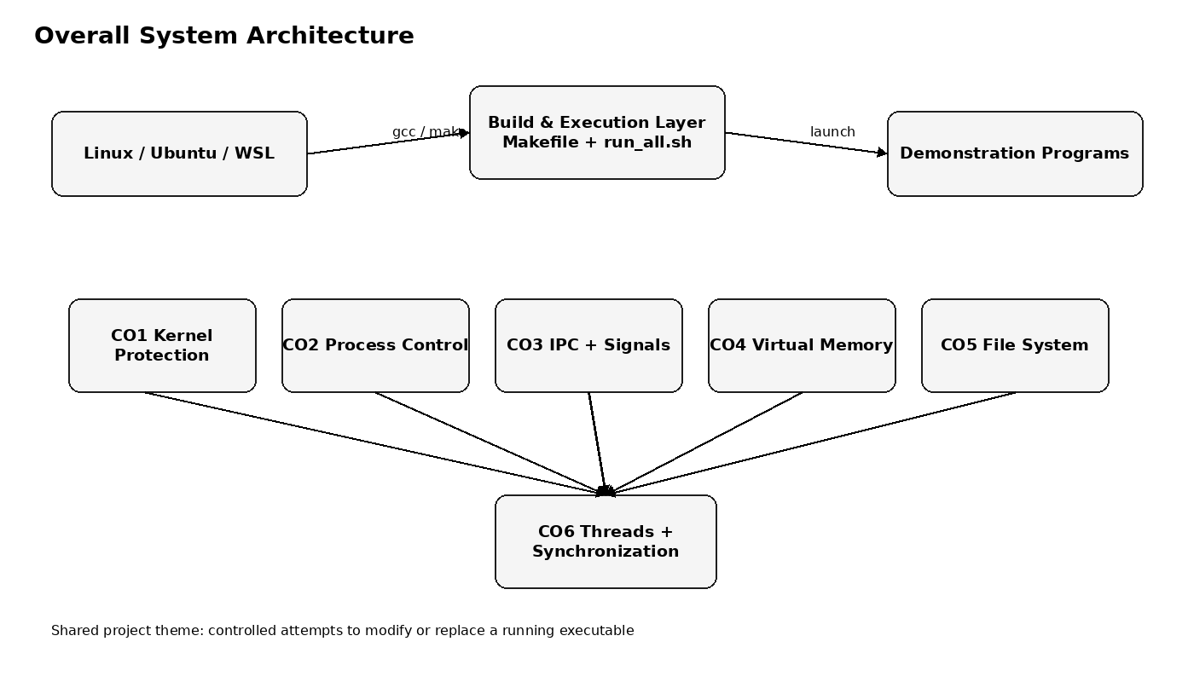
Figure 5.1: Overall System Architecture of the Demonstration Suite

5.2 System Workflow
- Place the project in an Ubuntu/Linux file system.
- Build all targets with make.
- Run one module directly or execute make run.
- CO1 attempts a write-open on its own running executable.
- CO2 creates a child and executes target_program; the parent attempts the write-open while the child is active.
- CO3 exchanges READY through a pipe and handles SIGCHLD after child termination.
- CO4 observes executable mappings and memory-write protection.
- CO5 creates a copy, inspects its inode and ELF header, tests running-file access, and performs a rename-based replacement.
- CO6 compares unsynchronized and synchronized counters, then coordinates concurrent executable-write attempts.
- run_all.sh proceeds to the next module after each program exits.
5.3 Flowchart / Data Flow
The main data/control flow is:
Build source files → executable binaries → launch demonstration → system call request → kernel decision → success/error → printed observation → resource cleanup.
For the central protection path, the important branch is:
Running executable? → Yes → open(O_WRONLY) requested → kernel rejects request → ETXTBSY → report denial → do not write. → No → the write-open may be permitted, subject to ordinary file permissions and other file-system conditions.
For CO5 replacement:
Running process uses inode A → create replacement inode B → rename replacement to same pathname → pathname resolves to inode B → running process continues with its already-open executable image/inode relationship → cleanup after termination.

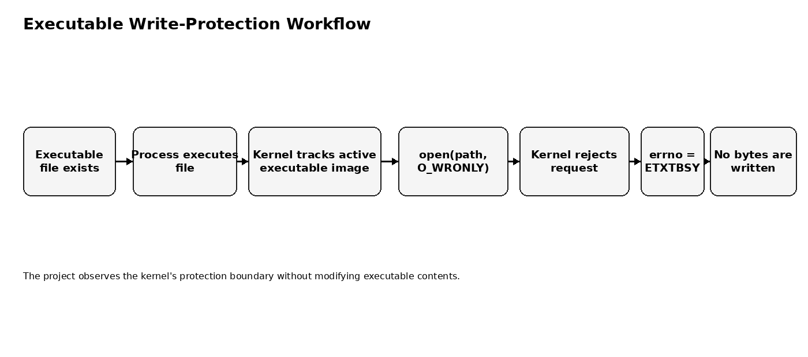
Figure 5.2: Central Executable Write-Protection Workflow

5.4 Module Description
CO1 – Kernel Protection: discovers its own executable path with readlink(), calls open(O_WRONLY), and checks errno for ETXTBSY.
CO2 – Process Control: parent calls fork(); child calls execve() for target_program; parent calls open(O_WRONLY) while the child is running and finally calls waitpid().
CO3 – IPC and Signals: creates a pipe before fork(); child writes READY; parent reads it; SIGCHLD handler reaps the child with waitpid(..., WNOHANG).
CO4 – Virtual Memory: reads /proc/self/maps; maps a page read-only; catches SIGSEGV from a write attempt; tests MAP_SHARED write permissions; demonstrates MAP_PRIVATE copy-on-write.
CO5 – File System: copies target_program with low-level I/O; examines inode/size/mode/link count; reads ELF magic; compares write/read access while running; demonstrates post-exit access and rename-based replacement.
CO6 – Thread Synchronization: compares unsafe and mutex-protected counters; creates six workers; limits simultaneous opens with a semaphore; protects shared state with a mutex; waits on a condition variable.
CO | Focus | Main mechanisms
CO1 | Kernel protection | readlink + open + errno/ETXTBSY
CO2 | Process control | fork + execve + waitpid
CO3 | IPC and signals | pipe + read/write + SIGCHLD
CO4 | Virtual memory | mmap + SIGSEGV + COW
CO5 | File system | stat + low-level I/O + rename
CO6 | Synchronization | pthread + mutex + semaphore + cond

5.5 Input and Output Design
The project is primarily demonstration-driven and uses command-line execution rather than interactive input. Inputs are supplied through command-line arguments only where implemented.
target_program optionally accepts a number of seconds; values greater than zero and less than 60 are accepted, otherwise the default duration of three seconds is retained. The other modules use fixed paths, constants, and internally defined experiment parameters.
Outputs are plain terminal text. They identify the step being executed and print relevant process IDs, paths, error codes, file descriptors, metadata, or memory values when those values are available at run time. System-dependent values such as PIDs, addresses, inode numbers, and exact output ordering must be captured from the actual execution environment rather than fabricated in this report.

CHAPTER -6 IMPLEMENTATION

6.1 Module-wise Implementation
The implementation is intentionally split into independent source files. CO1 is self-contained and requires no helper process. CO2 and CO5 use target_program as an executable child target. CO3 creates its own child and communication channel. CO4 operates on its own executable mapping. CO6 operates entirely within one process using multiple POSIX threads.
The source files share a common style: headers are included explicitly, failures are checked where appropriate, output is labeled by step, and resources such as file descriptors, mappings, threads, and synchronization objects are released before termination where the design requires it.
Module | Concept | Core implementation
CO1 | Kernel protection | /proc/self/exe; open(O_WRONLY); errno/ETXTBSY
CO2 | Process control | fork(); execve(); waitpid(); target_program
CO3 | IPC + signals | pipe(); read/write; sigaction(); SIGCHLD
CO4 | Virtual memory | /proc/self/maps; mmap(); SIGSEGV; MAP_PRIVATE
CO5 | File system | open/read/write; stat; lseek; rename; unlink
CO6 | Thread synchronization | pthread; mutex; semaphore; condition variable

6.2 Algorithm / Pseudocode
termination. Algorithm 1 – CO1:
- Read /proc/self/exe with readlink().
- Store the returned executable path.
- Call open(path, O_WRONLY).
- If open fails, inspect errno.
- If errno == ETXTBSY, report that the kernel denied the write-open.
- If open unexpectedly succeeds, close the descriptor without writing.
- Exit.
Algorithm 2 – CO2:
- Print parent PID.
- Call fork().
- In child: prepare argv/envp and call execve(target_program).
- In parent: wait briefly for execve() to complete.
- Call open(target_program, O_WRONLY).
- Report ETXTBSY if returned.
- Call waitpid(child, &status, 0).
- Report normal or signal termination.
Algorithm 3 – CO5 replacement:
- Copy target_program to demo_copy with open/read/write/close.
- stat() demo_copy and print metadata.
- Open it read-only and inspect its first four bytes.
- Launch demo_copy with fork()+execve().
- Attempt O_WRONLY and O_RDONLY while it runs.
- waitpid() for termination.
- Test O_WRONLY after exit.
- Launch it again.
- Create demo_copy.new.
- rename(demo_copy.new, demo_copy).
- Compare old/new inode information and wait for the running child.
- unlink() the demo file.
Algorithm 4 – CO6:
- Start four threads for the unsafe counter.
- Start four threads for the mutex-protected counter.
- Resolve /proc/self/exe.
- Initialize semaphore to two slots.
- Create six worker threads.
- Each worker waits on the semaphore, calls open(O_WRONLY), records errno, then updates shared state under a mutex.
- Last worker signals the condition variable.
- Main waits on the condition variable and then joins all workers.
- Print each result and destroy synchronization objects.

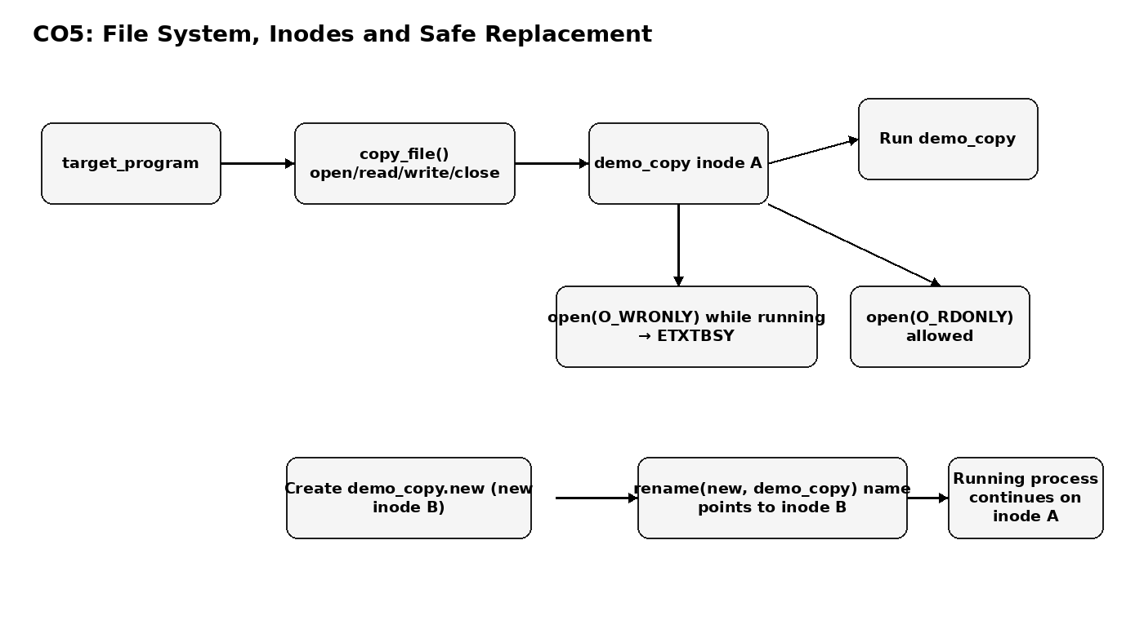
Figure 6.5: CO5 File-System and Safe Replacement Flow

6.3 Core C / C++ Implementation
The core implementation is C, with GNU11 compilation. Important code patterns include:
• readlink("/proc/self/exe", ...) to discover the current executable.
• open(path, O_WRONLY) to request write access without performing a write.
• errno and ETXTBSY to distinguish the protected executable case.
• fork() followed by execve() to create a live process image from target_program.
• waitpid() to collect child completion.
• mmap() with different protection and sharing flags.
• stat() to inspect inode-related metadata.
• rename() to replace a pathname with another file without writing into the running executable.
• pthread_create()/pthread_join(), mutexes, semaphores, and condition variables for concurrency.
The supplied source is the authoritative implementation; Appendix A contains the source files without functional rewriting.

6.4 Linux System Calls / APIs Used
| Interface | Module(s) | Purpose |
| readlink() | CO1, CO4, CO6 | Resolve /proc/self/exe |
| open()/close() | CO1, CO2, CO4, CO5, CO6 | Open executable or data file and release descriptor |
| errno / ETXTBSY | CO1, CO2, CO5, CO6 | Report and classify protected write-open failure |
| fork() | CO2, CO3, CO5 | Create child processes |
| execve() | CO2, CO5 | Replace child process image with executable |
| waitpid() | CO2, CO3, CO5 | Wait/reap child and obtain status |
| pipe(), read(), write() | CO3 | Anonymous IPC |
| sigaction(), SIGCHLD | CO3 | Install asynchronous child-termination handler |
| mmap(), munmap(), sysconf() | CO4 | Memory mappings and page-size information |
| SIGSEGV / siglongjmp() | CO4 | Recover from deliberate protection fault |
| stat(), lseek(), pread() | CO5 | Metadata and low-level file inspection |
| rename(), unlink() | CO5 | Safe pathname replacement and cleanup |
| pthread_* | CO6 | Thread lifecycle and synchronization |
| sem_* | CO6 | Limit concurrent worker attempts |
The exact error numbers, process IDs, descriptors, addresses, and inode values are runtime-dependent and are intentionally not fabricated.
Interface | Module(s) | Purpose
readlink() | CO1, CO4, CO6 | Resolve /proc/self/exe
open()/close() | CO1, CO2, CO4, CO5, CO6 | File access and descriptor management
fork()/execve()/waitpid() | CO2, CO5 | Process creation, image replacement, waiting
pipe()/read()/write() | CO3 | Anonymous IPC
sigaction()/SIGCHLD | CO3 | Asynchronous child notification
mmap()/munmap() | CO4 | Virtual-memory mapping
stat()/lseek()/pread() | CO5 | Metadata and file inspection
rename()/unlink() | CO5 | Replacement and cleanup
pthread_* | CO6 | Thread lifecycle and mutex/condition control
sem_* | CO6 | Counting semaphore

6.5 Process / Thread Implementation
CO2 uses the conventional process sequence fork() → execve() → waitpid(). fork() creates the child; execve() replaces the child’s process image with target_program; the parent remains active and can perform the write-open test; waitpid() then synchronizes with child termination.
CO6 uses pthread_create() and pthread_join(). Part A deliberately exposes a possible race on a shared counter by separating the read and write of the counter and occasionally calling sched_yield(). Part A then repeats the operation inside a mutex-protected critical section.
In Part B, six worker threads execute the same open attempt. The semaphore limits the number of workers entering the attempt region at one time. Shared result bookkeeping is protected by state_lock.
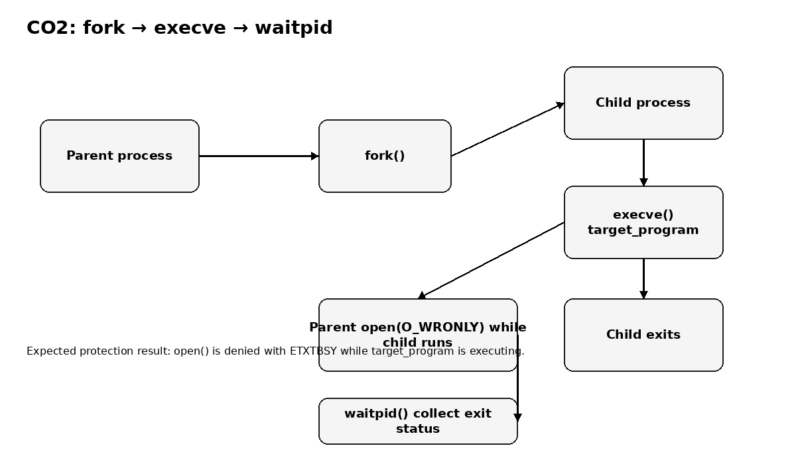
Figure 6.1: CO2 Process Lifecycle and Write-Protection Observation
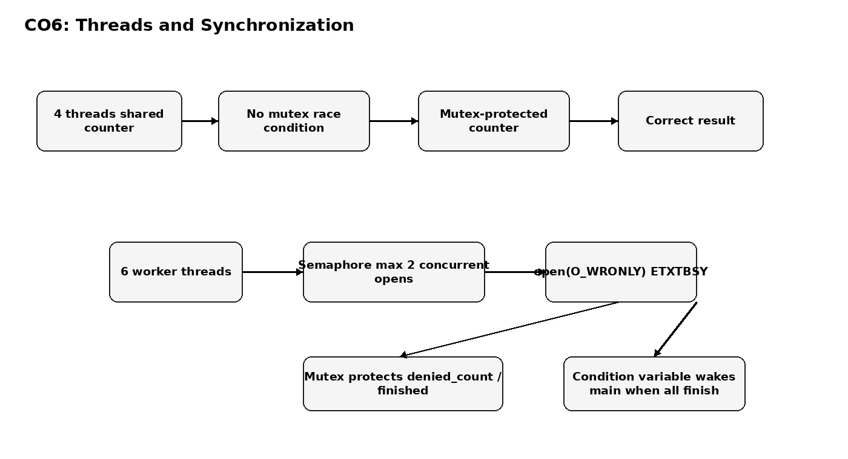
Figure 6.2: CO6 Thread Synchronization Design

6.6 IPC / Synchronization Implementation
CO3 demonstrates two communication styles. The pipe is created before fork(), so the parent and child inherit the two pipe descriptors. The child closes the read end and writes READY to the write end. The parent closes the write end and reads the message.
The same program installs a SIGCHLD handler before fork(). When the child terminates, the kernel delivers SIGCHLD to the parent. The handler calls waitpid(-1, NULL, WNOHANG) in a loop to reap terminated children and sets a volatile sig_atomic_t flag. The source itself notes that printf() inside the signal handler is not strictly async-signal-safe; it is retained for this educational demonstration.
CO6 uses mutexes, a counting semaphore, and a condition variable. The main thread waits while finished < WORKERS and is awakened when the last worker signals all_done.
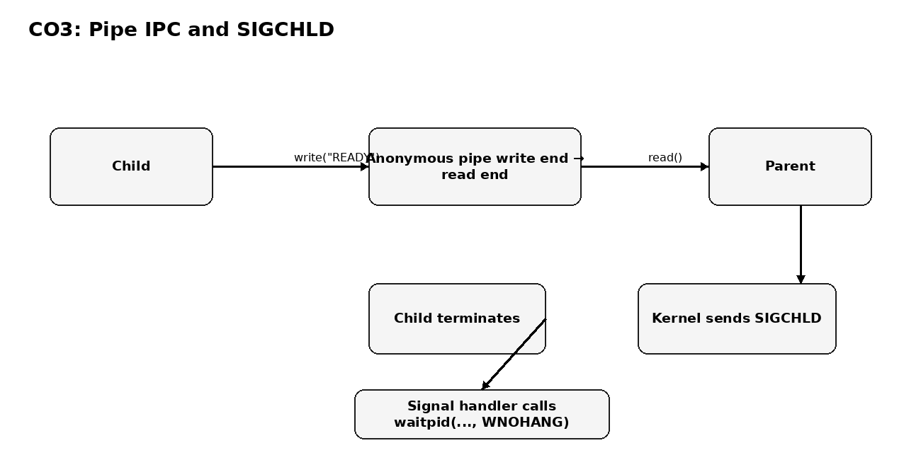
Figure 6.3: CO3 Pipe Communication and SIGCHLD Flow

6.7 Memory Management Implementation
CO4 demonstrates memory protection from the process side. The program reads /proc/self/maps to display mappings associated with its executable, stack, and heap. It then creates a PROT_READ private mapping of the executable and deliberately attempts to write through it. The signal handler catches SIGSEGV and returns to a safe point.
The next experiment requests a PROT_READ | PROT_WRITE MAP_SHARED mapping from a read-only descriptor. The source expects mmap() to reject the request because a shared writable mapping would require write access to the underlying file.
Finally, the program requests MAP_PRIVATE with read/write protection. The first write is handled using copy-on-write semantics, so the private memory page can change while the byte read directly from the file descriptor remains unchanged.
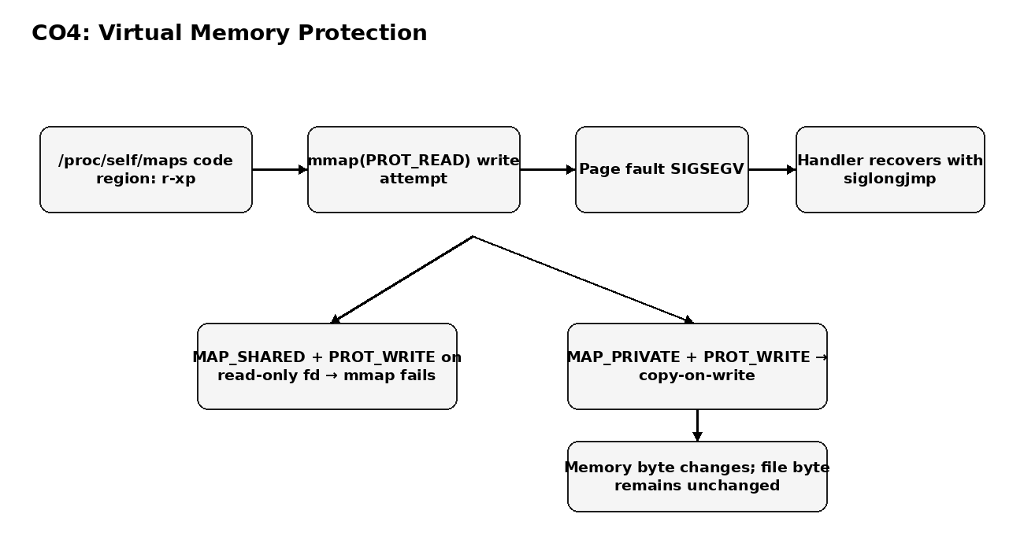
Figure 6.4: CO4 Virtual-Memory Protection and Copy-on-Write

6.8 Optional User Interface Implementation
No graphical or web user interface is implemented. The project is a command-line Linux systems-programming demonstration. Terminal headings, step labels, and explanatory messages are the only user-facing presentation layer in the supplied code.

CHAPTER -7 EXECUTION AND DEMONSTRATION
7.1 Compilation in Ubuntu
The supplied README recommends installing the required build tools first:
sudo apt update sudo apt install -y build-essential gdb
Then, from the project directory:
make
The Makefile compiles all seven targets using GCC with -Wall -Wextra -g -std=gnu11 and links with -pthread. A successful build should create the six CO executables and target_program. The actual compiler transcript is not included in the supplied project archive and must be captured from the student’s Linux environment if required.
7.2 Execution Commands
The README gives these main execution options:
./CO1_Kernel_Protection ./CO2_Process_Control ./CO3_IPC_Signals ./CO4_Virtual_Memory ./CO5_File_System ./CO6_Thread_Sync
or:
make run
The run target first builds all programs and then invokes run_all.sh. The script changes to the project directory, checks that each executable exists and is executable, runs CO1 through CO6 sequentially, and stops with a message if a required binary is missing.
The helper can also be run directly:
./target_program [seconds]
The source accepts a positive duration below 60 seconds; otherwise it retains its default of three seconds.
7.3 Sample Inputs and Outputs
The programs are mostly non-interactive. The report therefore distinguishes expected output from actual captured output.
Expected CO1 outcome: the program prints its executable path and PID, attempts open(O_WRONLY), reports WRITE DENIED, and identifies ETXTBSY when the Linux environment enforces the expected behavior.
Expected CO2 outcome: the child executes target_program, the parent attempts to open the same executable for writing, and the parent reports ETXTBSY while the child is running.
Expected CO3 outcome: the parent receives the string READY through the pipe and later reports receipt of SIGCHLD after child termination.
Expected CO4 outcome: the program displays memory mappings, catches SIGSEGV for the read-only write attempt, reports failure of the shared writable mapping, and shows that a private mapping can change without changing the file byte.
Expected CO5 outcome: the running copy rejects O_WRONLY, permits O_RDONLY, permits O_WRONLY after exit, and allows rename() to replace the pathname with a new inode.
Expected CO6 outcome: the unsafe counter may be lower than the expected value on a particular run or may happen to match; the mutex-protected counter is expected to match the computed expected value. The worker results are printed individually.
[INSERT ACTUAL TERMINAL OUTPUT FROM LINUX EXECUTION HERE]
Module | Input | Expected observation / actual-data requirement
CO1 | No interactive input | Expected: WRITE DENIED / ETXTBSY; actual terminal output must be captured
CO2 | Fixed target path | Expected: parent denied while child runs; actual PID/status must be captured
CO3 | Fixed READY message | Expected: READY + SIGCHLD; actual output must be captured
CO4 | Fixed mapping tests | Expected: SIGSEGV handling/COW; addresses and bytes are runtime-dependent
CO5 | Generated demo_copy | Expected: write denied while running, rename succeeds; inode values must be captured
CO6 | Fixed thread counts | Expected: synchronized counter correct; unsafe result may vary

7.4 Screenshots of Execution
The uploaded project archive contains source code and configuration but does not contain execution screenshots. Therefore, no screenshot is fabricated in this report.
Insert the following actual screenshots after running the project in Ubuntu/WSL:
Figure 7.1: Successful Project Compilation [INSERT ACTUAL UBUNTU TERMINAL SCREENSHOT]
Figure 7.2: CO1 ETXTBSY Write-Protection Demonstration [INSERT ACTUAL UBUNTU TERMINAL SCREENSHOT]
Figure 7.3: CO2 fork(), execve(), and waitpid() Execution [INSERT ACTUAL UBUNTU TERMINAL SCREENSHOT]
Figure 7.4: CO3 Pipe and SIGCHLD Execution [INSERT ACTUAL UBUNTU TERMINAL SCREENSHOT]
Figure 7.5: CO4 Virtual-Memory Protection and Copy-on-Write [INSERT ACTUAL UBUNTU TERMINAL SCREENSHOT]
Figure 7.6: CO5 Inode and rename() Demonstration [INSERT ACTUAL UBUNTU TERMINAL SCREENSHOT]
Figure 7.7: CO6 Thread Synchronization Execution [INSERT ACTUAL UBUNTU TERMINAL SCREENSHOT]
Figure 7.1: Successful Project Compilation [INSERT ACTUAL UBUNTU TERMINAL SCREENSHOT]
Figure 7.2: CO1 ETXTBSY Write Protection [INSERT ACTUAL TERMINAL SCREENSHOT]
Figure 7.3: CO2 Process Control [INSERT ACTUAL TERMINAL SCREENSHOT]
Figure 7.4: CO3 Pipe and SIGCHLD [INSERT ACTUAL TERMINAL SCREENSHOT]
Figure 7.5: CO4 Virtual Memory [INSERT ACTUAL TERMINAL SCREENSHOT]
Figure 7.6: CO5 File System and rename() [INSERT ACTUAL TERMINAL SCREENSHOT]
Figure 7.7: CO6 Thread Synchronization [INSERT ACTUAL TERMINAL SCREENSHOT]
7.5 Demonstration of OS Concepts
The final demonstration should connect each observable output to an OS concept:
CO1 → user-space open() request is rejected by kernel policy for an executing executable image → ETXTBSY.
CO2 → process creation and image replacement → the parent can observe the executable while the child is executing it.
CO3 → kernel-supported IPC and asynchronous notification → pipe transfers READY, while SIGCHLD reports child termination.
CO4 → virtual-memory permissions and page faults → a read-only mapping cannot be written; MAP_PRIVATE permits a private modified copy.
CO5 → file descriptors and inode identity → a running process can continue using the old file object while a pathname is atomically redirected by rename() to a replacement file.
CO6 → concurrency control → unsynchronized shared state can race, while mutexes, semaphores, and condition variables coordinate threads.
These demonstrations are complementary rather than independent features of an application: together they show how the operating system protects executable integrity across multiple abstraction layers.
CHAPTER -8 CONCLUSION 8.1 Summary of the Project
“Denying Writes to Executables” is a Linux C-based Operating Systems and Systems Programming project centered on the behavior of a running executable. The implementation uses six independent demonstrations to connect executable protection with process control, IPC, signals, virtual memory, file systems, and thread synchronization.
The central observation is that a direct O_WRONLY open of an executable image that is currently being executed can be denied with ETXTBSY. The project then explains why replacement through rename() is a different operation from modifying the contents of the currently used executable file.
8.2 Objectives Achieved
The source code implements all six planned course-outcome demonstrations. It provides explicit demonstrations of:
• kernel-level executable write protection; • fork(), execve(), and waitpid(); • pipe-based IPC and SIGCHLD; • memory permissions, SIGSEGV, mmap(), and copy-on-write; • inode/file-descriptor behavior and rename-based replacement; • POSIX thread races and synchronization.
The report does not claim a successful empirical run because no terminal execution transcript was supplied with the archive. The implementation itself supports the stated objectives, while actual observed outputs should be inserted in Chapter 7.
8.3 Results Achieved
The code defines the expected observations, but runtime-specific results such as PIDs, file descriptors, inode numbers, memory addresses, exact error numbers, and scheduling-dependent counter values were not supplied. They are therefore intentionally left for capture during the final demonstration.
Expected results from the implementation are:
- ETXTBSY for protected write-open attempts on the running executable.
- Normal process lifecycle in CO2 with parent waiting for the child.
- READY delivery through a pipe and SIGCHLD notification in CO3.
- SIGSEGV for the deliberate write to a read-only mapping and unchanged on-disk data after a private copy-on-write modification in CO4.
- Different inode identity after rename-based replacement in CO5, with the running process continuing on its original file object.
- Correct mutex-protected counter and coordinated worker completion in CO6.
[INSERT ACTUAL RESULT TABLE / OUTPUT AFTER FINAL EXECUTION]
8.4 Skills and Learning Outcomes
The project develops practical skills in:
• Linux system-call programming in C. • Process creation and executable image replacement. • IPC through anonymous pipes. • Signal handling and child reaping. • Virtual-memory mapping and page protection. • File metadata and inode analysis. • Safe file replacement concepts. • POSIX thread creation and joining. • Mutex, semaphore, and condition-variable synchronization. • GNU Make, GCC, GDB, Bash, and VS Code/WSL workflows. • Reading kernel-visible information through /proc. • Designing safe experiments that observe protected operations without corrupting files.
CHAPTER -9 REFERENCES 9.1 Books
[1] Abraham Silberschatz, Peter Baer Galvin, and Greg Gagne, Operating System Concepts, Wiley.
[2] Robert Love, Linux Kernel Development, Addison-Wesley.
[3] Michael Kerrisk, The Linux Programming Interface, No Starch Press.
9.2 Research Papers
The supplied project archive does not cite a specific research paper. To avoid fabricating literature claims, this section records that no project-specific research paper was provided in the source archive.
For the final academic submission, any paper cited in the literature survey should be verified against the actual paper and cited consistently with the university's required reference style.
9.3 Linux / GNU Documentation
[4] Linux man-pages project, open(2): documents ETXTBSY for a path referring to an executable image currently being executed when write access is requested.
[5] Linux man-pages project, mmap(2): documents memory mappings and MAP_PRIVATE/MAP_SHARED behavior.
[6] Linux man-pages project, fork(2), execve(2), and waitpid(2): process creation, executable image replacement, and process waiting.
[7] GNU C Library documentation, POSIX Threads: thread creation and synchronization interfaces.
[8] GNU C Library documentation, POSIX mutexes and related synchronization facilities.
9.4 Online Resources
[9] Linux man-pages: https://man7.org/linux/man-pages/
[10] GNU C Library documentation: https://sourceware.org/glibc/manual/
[11] GCC documentation: https://gcc.gnu.org/onlinedocs/
[12] Visual Studio Code C/C++ documentation: https://code.visualstudio.com/docs/languages/cpp
Note: Online references should be checked at the time of final submission for institutional citation requirements and access dates.

APPENDIX A – SOURCE CODE
The following source listings are reproduced from the supplied project archive. They are included for documentation and viva reference. No functional rewriting has been performed.

CO1_Kernel_Protection.c
/* =====================================================================
* CO1_Kernel_Protection.c
* ---------------------------------------------------------------------
* COURSE OUTCOME 1 (CO-1): Operating System Concepts, System Calls,
* Kernel Space vs User Space
*
* CONCEPT DEMONSTRATED:
* ----------------------
* The Linux kernel does NOT allow a process to open a currently
* EXECUTING binary file in write mode. If you try to do so, the
* open() system call fails and sets errno to ETXTBSY
* ("Text file busy").
*
* This is a real kernel-level protection mechanism: while a program's
* code (its "text segment") is loaded into memory and running, the
* kernel marks that file as busy so that no one can modify the bytes
* of a program while the CPU is actively executing them. This keeps
* the system stable and prevents corruption of running code.
*
* HOW THIS PROGRAM DEMONSTRATES IT SAFELY:
* ------------------------------------------
* This program finds the path of its OWN executable file (the very
* file that is currently running as this process) using the special
* Linux symlink /proc/self/exe. Then, while it is still running, it
* calls open() on that same path with O_WRONLY (write-only) mode.
*
* Since this program itself is the "currently running executable",
* the kernel will refuse the request and open() will return -1 with
* errno set to ETXTBSY. We never actually write anything to the file,
* so nothing is corrupted -- we only PROVE that the kernel blocked us.
*
* SYSTEM CALLS / CONCEPTS USED:
* - open() : user-space request that crosses into
* kernel space (a system call)
* - file descriptors : what open() would normally return
* - errno : how the kernel reports failure reasons
* back to user space
* - ETXTBSY : the specific error code for this
* protection mechanism
* - readlink() : used to discover our own executable path
* =====================================================================
*/

#define _DEFAULT_SOURCE /* needed so readlink() is visible with -std=c99 */

#include <stdio.h>
#include <stdlib.h>
#include <unistd.h>
#include <fcntl.h> /* open(), O_WRONLY */
#include <errno.h> /* errno, ETXTBSY */
#include <string.h>

int main(void)
{
char exe_path[1024];
ssize_t len;

printf("=====================================================\n");
printf(" Kernel Protection: Writing to a Running Executable\n");
printf("=====================================================\n\n");

printf("Step 1: Discovering the path of my own running executable...\n");

/*
* /proc/self/exe is a special symbolic link maintained by the
* Linux kernel. It always points to the executable file of the
* process that is reading it (i.e., THIS program).
*/
len = readlink("/proc/self/exe", exe_path, sizeof(exe_path) - 1);
if (len == -1)
{
perror("readlink failed");
exit(EXIT_FAILURE);
}
exe_path[len] = '\0'; /* readlink does not null-terminate */

printf(" -> My executable path is: %s\n", exe_path);
printf(" -> My Process ID (PID) is: %d\n\n", getpid());

printf("Step 2: Attempting to open my own executable for WRITING\n");
printf(" while it is currently running...\n\n");

printf("Attempting to open executable for writing...\n");

/*
* THE IMPORTANT SYSTEM CALL:
* We ask the kernel to open our own running binary in write mode.
* Because this file is presently being executed (its text segment
* is mapped and active), the kernel is expected to deny this.
*/
int fd = open(exe_path, O_WRONLY);

if (fd == -1)
{
/* The open() system call failed. Inspect errno to find out why. */
printf("WRITE DENIED\n");
printf("errno = %d\n", errno);

if (errno == ETXTBSY)
{
printf("ETXTBSY: Text file busy\n");
printf("Linux kernel prevented the write.\n\n");
printf("EXPLANATION:\n");
printf("The kernel refused to let us open this executable\n");
printf("for writing because it is currently being executed\n");
printf("as a running process. This protects the integrity\n");
printf("of running programs and demonstrates how the kernel\n");
printf("enforces boundaries between user-space requests and\n");
printf("protected system resources.\n");
}
else
{
/* In case some other error occurred, still show it clearly */
printf("(Unexpected error) %s\n", strerror(errno));
}
}
else
{
/*
* If we somehow succeeded (should not normally happen while
* running), we safely close the descriptor without writing
* any data, so the executable is never corrupted.
*/
printf("Unexpectedly succeeded in opening the file for write.\n");
printf("No data will be written -- closing file descriptor %d now.\n", fd);
close(fd);
}

printf("\n=====================================================\n");
printf(" Demonstration complete.\n");
printf("=====================================================\n");

return 0;
}

CO2_Process_Control.c
/* =====================================================================
* CO2_Process_Control.c
* ---------------------------------------------------------------------
* Process control: fork() -> execve() -> waitpid()
*
* Parent --fork()--> Child --execve()--> target_program runs
* Parent waits with waitpid() and reads the exit status.
*
* Link to the project theme: while the child is running
* target_program, the parent tries to open that same file for writing.
* The kernel answers with ETXTBSY, because the file is now the
* executable image of a live process.
*
* System calls: fork, execve, waitpid, getpid, getppid, open, usleep
* ===================================================================== */

#define _DEFAULT_SOURCE

#include <stdio.h>
#include <stdlib.h>
#include <string.h>
#include <unistd.h>
#include <fcntl.h>
#include <errno.h>
#include <sys/types.h>
#include <sys/wait.h>

#define TARGET_PATH "./target_program"

int main(void)
{
printf("=====================================================\n");
printf(" Process Control Demo: fork -> exec -> wait\n");
printf("=====================================================\n\n");

printf("[Parent] My PID = %d\n", getpid());
printf("[Parent] Creating a child process using fork()...\n\n");
fflush(stdout); /* avoid duplicated buffered output in the child */

pid_t pid = fork();
if (pid < 0) {
perror("fork failed");
exit(EXIT_FAILURE);
}

if (pid == 0) {
/* ------------------------- CHILD ------------------------- */
printf("[Child ] Created. My PID = %d, my parent's PID = %d\n",
getpid(), getppid());
printf("[Child ] Replacing myself with target_program using execve()...\n\n");
fflush(stdout);

char *args[] = { TARGET_PATH, NULL };
char *envp[] = { NULL };
execve(TARGET_PATH, args, envp);

perror("execve failed (did you run 'make' first?)");
_exit(EXIT_FAILURE);
}

/* --------------------------- PARENT --------------------------- */
printf("[Parent] Child launched with PID = %d\n", pid);

usleep(500000); /* give the child time to finish execve() */

printf("[Parent] While the child runs, I try to open %s for writing...\n",
TARGET_PATH);
int fd = open(TARGET_PATH, O_WRONLY);
if (fd == -1) {
printf("[Parent] WRITE DENIED -> errno = %d (%s)\n", errno, strerror(errno));
if (errno == ETXTBSY)
printf("[Parent] The kernel protects the running executable.\n");
} else {
printf("[Parent] open() succeeded (nothing is written). Closing it.\n");
close(fd);
}

printf("[Parent] Waiting for the child to terminate...\n\n");
fflush(stdout);

int status;
pid_t done = waitpid(pid, &status, 0);

printf("\n[Parent] waitpid() returned: child %d has terminated.\n", done);
if (WIFEXITED(status))
printf("[Parent] Child exited normally with exit code %d.\n", WEXITSTATUS(status));
else if (WIFSIGNALED(status))
printf("[Parent] Child was killed by signal %d.\n", WTERMSIG(status));

printf("\n=====================================================\n");
printf(" Demonstration complete.\n");
printf("=====================================================\n");
return 0;
}

CO3_IPC_Signals.c
/* =====================================================================
* CO3_IPC_Signals.c
* ---------------------------------------------------------------------
* COURSE OUTCOME 3 (CO-3): Inter-Process Communication (IPC) and Signals
*
* CONCEPT DEMONSTRATED:
* ----------------------
* Child process
* |
* pipe() -> an anonymous, one-way IPC channel
* | is created before forking
* Send "READY" message -----> written by child into the pipe
* |
* Parent receives "READY" -> parent reads the message
* |
* Child terminates
* |
* SIGCHLD -> kernel sends this signal to the
* | parent automatically
* Parent handles termination -> a signal handler function runs
*
* SYSTEM CALLS / CONCEPTS USED:
* - pipe() : creates an anonymous pipe (two file
* descriptors: read end and write end)
* - fork() : creates the child process
* - read() / write() : used to send data through the pipe
* - sigaction() : installs a signal handler for SIGCHLD
* - SIGCHLD : signal automatically sent to a parent
* process when one of its children
* terminates (asynchronous notification)
* - waitpid() (in handler) : reaps the terminated child safely
*
* This program shows TWO different ways a child can communicate
* information to its parent:
* 1. Synchronously through a pipe ("READY" message)
* 2. Asynchronously through a signal (SIGCHLD on termination)
* =====================================================================
*/

#define _POSIX_C_SOURCE 200809L /* needed for sigaction()/SA_RESTART with -std=c99 */

#include <stdio.h>
#include <stdlib.h>
#include <string.h>
#include <unistd.h>
#include <signal.h>
#include <errno.h>
#include <sys/types.h>
#include <sys/wait.h>

/* This flag is set by the signal handler when SIGCHLD arrives.
* It is declared 'volatile sig_atomic_t' because it is modified
* inside a signal handler (async-signal-safe practice). */
volatile sig_atomic_t child_terminated = 0;

/* ---------------------------------------------------------------------
* Signal handler for SIGCHLD.
* This function runs ASYNCHRONOUSLY -- the kernel invokes it whenever
* a child process of ours terminates, interrupting whatever the parent
* was doing at that moment.
* -------------------------------------------------------------------*/
void sigchld_handler(int signum)
{
(void)signum; /* unused parameter */

/* Reap the child to prevent a zombie process.
* We keep this handler simple and safe for a college project. */
int saved_errno = errno;
while (waitpid(-1, NULL, WNOHANG) > 0)
{
/* loop in case multiple children exited */
}
errno = saved_errno;

child_terminated = 1;

/* NOTE: printf() is not strictly "async-signal-safe", but for a
* simple educational demonstration on Linux it works reliably and
* makes the output easy to understand. */
printf("[Parent] >>> SIGCHLD received! Kernel notified us that the "
"child has terminated. <<<\n");
}

int main(void)
{
int pipe_fd[2]; /* pipe_fd[0] = read end, pipe_fd[1] = write end */
char buffer[100];

printf("=====================================================\n");
printf(" IPC Demo: Pipe and SIGCHLD Signal\n");
printf("=====================================================\n\n");

/* -----------------------------------------------------------
* STEP 1: Create the pipe BEFORE forking, so that both parent
* and child inherit the same pipe file descriptors.
* -----------------------------------------------------------
*/
if (pipe(pipe_fd) == -1)
{
perror("pipe failed");
exit(EXIT_FAILURE);
}
printf("[Parent] Pipe created. Read end = %d, Write end = %d\n",
pipe_fd[0], pipe_fd[1]);

/* -----------------------------------------------------------
* STEP 2: Install the SIGCHLD signal handler BEFORE forking,
* so the parent is ready to catch the signal at any time.
* -----------------------------------------------------------
*/
struct sigaction sa;
memset(&sa, 0, sizeof(sa));
sa.sa_handler = sigchld_handler;
sigemptyset(&sa.sa_mask);
sa.sa_flags = SA_RESTART; /* restart interrupted system calls */

if (sigaction(SIGCHLD, &sa, NULL) == -1)
{
perror("sigaction failed");
exit(EXIT_FAILURE);
}
printf("[Parent] SIGCHLD handler installed.\n\n");

/* IMPORTANT: flush stdout BEFORE fork().
* printf() output is line-buffered/block-buffered in memory before
* it is actually written out. If we fork() while text is still
* sitting in that buffer, BOTH the parent and the child inherit a
* copy of the buffer and each of them will print it again later,
* causing confusing duplicate output. Flushing first avoids this. */
fflush(stdout);

pid_t pid = fork();

if (pid < 0)
{
perror("fork failed");
exit(EXIT_FAILURE);
}

if (pid == 0)
{
/* --------------------- CHILD PROCESS ------------------------ */

/* The child only needs the WRITE end of the pipe, so close
* the unused READ end. */
close(pipe_fd[0]);

printf("[Child ] My PID is %d. Sending READY message through "
"the pipe...\n", getpid());

const char *msg = "READY";
write(pipe_fd[1], msg, strlen(msg) + 1);

close(pipe_fd[1]); /* done writing */

printf("[Child ] Message sent. Now doing a little work and "
"then exiting...\n");
sleep(2);

printf("[Child ] Terminating now (this will trigger SIGCHLD "
"in the parent).\n");
exit(0);
}
else
{
/* --------------------- PARENT PROCESS ------------------------ */

/* The parent only needs the READ end of the pipe, so close
* the unused WRITE end. */
close(pipe_fd[1]);

printf("[Parent] Child process created with PID = %d\n", pid);
printf("[Parent] Waiting to receive message from child via "
"pipe...\n");

ssize_t n = read(pipe_fd[0], buffer, sizeof(buffer) - 1);
if (n > 0)
{
buffer[n] = '\0';
printf("[Parent] Received message from child: \"%s\"\n\n",
buffer);
}

close(pipe_fd[0]);

printf("[Parent] Now waiting for asynchronous SIGCHLD "
"notification when the child terminates...\n");

/* The parent can keep doing other things here. We simply
* pause/sleep until the SIGCHLD handler sets the flag,
* demonstrating that the notification is asynchronous. */
while (!child_terminated)
{
printf("[Parent] (still waiting... doing other work)\n");
sleep(1);
}

printf("\n[Parent] Confirmed: child process has fully "
"terminated and was reaped.\n");

printf("\n=====================================================\n");
printf(" Demonstration complete.\n");
printf("=====================================================\n");
}

return 0;
}

CO4_Virtual_Memory.c
/* =====================================================================
* CO4_Virtual_Memory.c
* ---------------------------------------------------------------------
* Virtual memory: how the MMU/kernel protect program code.
*
* A running executable is mapped into the process's virtual address
* space as a READ + EXECUTE region (r-xp) -- never writable. This
* program shows that protection from the memory side:
*
* Step 1 Show the executable's own mappings in /proc/self/maps.
* Step 2 Map the executable file read-only and try to write to it
* -> the MMU raises a page fault, the kernel sends SIGSEGV.
* We catch it with sigaction + siglongjmp and carry on.
* Step 3 mmap(PROT_WRITE, MAP_SHARED) on a read-only descriptor
* -> the kernel refuses (EACCES): a shared writable mapping
* would modify the file on disk.
* Step 4 mmap(PROT_WRITE, MAP_PRIVATE): allowed, but copy-on-write.
* The write goes to a private copy of the page; the file on
* disk stays unchanged (verified with pread()).
*
* Concepts: virtual address space, page permissions, page fault,
* SIGSEGV, copy-on-write, mmap, /proc/self/maps
* ===================================================================== */

#define _GNU_SOURCE

#include <stdio.h>
#include <stdlib.h>
#include <string.h>
#include <unistd.h>
#include <fcntl.h>
#include <errno.h>
#include <signal.h>
#include <setjmp.h>
#include <sys/mman.h>
#include <sys/stat.h>

static sigjmp_buf jump_point;
static volatile sig_atomic_t caught_segv = 0;

static void segv_handler(int signum)
{
(void)signum;
caught_segv = 1;
siglongjmp(jump_point, 1); /* leave the faulting instruction */
}

static void print_own_mappings(const char *exe_path)
{
FILE *f = fopen("/proc/self/maps", "r");
if (!f) { perror("fopen /proc/self/maps"); return; }

char line[512];
printf(" %-34s %-5s %s\n", "address range", "perms", "backing");
while (fgets(line, sizeof line, f)) {
if (strstr(line, exe_path) || strstr(line, "[stack]") || strstr(line, "[heap]")) {
char range[64], perms[8], off[32], dev[16], inode[32], path[400] = "";
if (sscanf(line, "%63s %7s %31s %15s %31s %399[^\n]",
range, perms, off, dev, inode, path) >= 5)
printf(" %-34s %-5s %s\n", range, perms, path[0] ? path : "[anonymous]");
}
}
fclose(f);
}

int main(void)
{
char exe_path[1024];
ssize_t len = readlink("/proc/self/exe", exe_path, sizeof exe_path - 1);
if (len == -1) { perror("readlink"); return EXIT_FAILURE; }
exe_path[len] = '\0';

printf("=====================================================\n");
printf(" Virtual Memory Demo: Protected Executable Mappings\n");
printf("=====================================================\n\n");

long page = sysconf(_SC_PAGESIZE);
printf("Page size on this system: %ld bytes\n", page);
printf("Executable: %s\n\n", exe_path);

/* ---------------- Step 1 ---------------- */
printf("Step 1: Memory map of this running process\n");
print_own_mappings(exe_path);
printf(" -> The code segment is 'r-xp': readable + executable,\n");
printf(" but NOT writable.\n\n");

int fd = open(exe_path, O_RDONLY);
if (fd == -1) { perror("open"); return EXIT_FAILURE; }

/* ---------------- Step 2 ---------------- */
printf("Step 2: Write into a read-only mapping of the executable\n");
unsigned char *ro = mmap(NULL, (size_t)page, PROT_READ, MAP_PRIVATE, fd, 0);
if (ro == MAP_FAILED) { perror("mmap"); return EXIT_FAILURE; }
printf(" Mapped first page at %p (PROT_READ). First byte = 0x%02x\n", (void *)ro, ro[0]);

struct sigaction sa;
memset(&sa, 0, sizeof sa);
sa.sa_handler = segv_handler;
sigemptyset(&sa.sa_mask);
sigaction(SIGSEGV, &sa, NULL);

printf(" Attempting to write to it...\n");
fflush(stdout);
if (sigsetjmp(jump_point, 1) == 0) {
ro[0] = 0x00; /* page fault -> SIGSEGV */
printf(" (unexpected) write succeeded\n");
}
if (caught_segv)
printf(" WRITE DENIED: page fault -> SIGSEGV caught.\n"
" The MMU blocked the write; the kernel reported it as a signal.\n\n");
signal(SIGSEGV, SIG_DFL);
munmap(ro, (size_t)page);

/* ---------------- Step 3 ---------------- */
printf("Step 3: Shared writable mapping on a read-only file descriptor\n");
void *sh = mmap(NULL, (size_t)page, PROT_READ | PROT_WRITE, MAP_SHARED, fd, 0);
if (sh == MAP_FAILED) {
printf(" WRITE DENIED: mmap() failed, errno = %d (%s)\n\n", errno, strerror(errno));
} else {
printf(" (unexpected) mapping created\n\n");
munmap(sh, (size_t)page);
}

/* ---------------- Step 4 ---------------- */
printf("Step 4: Private writable mapping (copy-on-write)\n");
unsigned char *priv = mmap(NULL, (size_t)page, PROT_READ | PROT_WRITE,
MAP_PRIVATE, fd, 0);
if (priv == MAP_FAILED) { perror("mmap private"); close(fd); return EXIT_FAILURE; }

unsigned char before_map = priv[0];
priv[0] = 0xFF; /* triggers a COW page copy */
unsigned char disk_byte = 0;
if (pread(fd, &disk_byte, 1, 0) != 1) perror("pread");

printf(" Byte 0 in memory before write : 0x%02x\n", before_map);
printf(" Byte 0 in memory after write : 0x%02x (private copy)\n", priv[0]);
printf(" Byte 0 of the file on disk : 0x%02x (unchanged)\n", disk_byte);
printf(" -> The kernel copied the page on first write, so the\n");
printf(" executable file itself was never modified.\n");

munmap(priv, (size_t)page);
close(fd);

printf("\n=====================================================\n");
printf(" Demonstration complete.\n");
printf("=====================================================\n");
return 0;
}

CO5_File_System.c
/* =====================================================================
* CO5_File_System.c
* ---------------------------------------------------------------------
* File systems and file I/O: inodes, file descriptors, and why a
* running executable cannot be written to -- but CAN be replaced.
*
* Steps:
* 1. Make a private copy of target_program (open/read/write/close).
* 2. Inspect the copy: inode number, size, permissions, link count
* (stat) and its ELF header (open/read/lseek).
* 3. Run the copy with fork()+execve(). While it runs, try
* open(O_WRONLY) -> ETXTBSY, but open(O_RDONLY) still works.
* 4. After the process exits, open(O_WRONLY) works again.
* 5. Start it again and REPLACE the file with rename(). This is
* allowed: the new file has a NEW inode, while the running
* process keeps using the OLD inode. This is how package
* managers update programs that are in use.
*
* System calls: open, read, write, lseek, close, fstat, stat, rename,
* unlink, fork, execve, waitpid
* ===================================================================== */

#define _DEFAULT_SOURCE

#include <stdio.h>
#include <stdlib.h>
#include <string.h>
#include <unistd.h>
#include <fcntl.h>
#include <errno.h>
#include <sys/types.h>
#include <sys/stat.h>
#include <sys/wait.h>

#define SOURCE_PATH "./target_program"
#define COPY_PATH "./demo_copy"
#define NEW_PATH "./demo_copy.new"

/* Copy a file using low-level file I/O. Returns 0 on success. */
static int copy_file(const char *src, const char *dst)
{
int in = open(src, O_RDONLY);
if (in == -1) { perror("open source (run 'make' first)"); return -1; }

int out = open(dst, O_WRONLY | O_CREAT | O_TRUNC, 0755);
if (out == -1) { perror("open destination"); close(in); return -1; }

char buf[4096];
ssize_t n;
while ((n = read(in, buf, sizeof buf)) > 0) {
if (write(out, buf, (size_t)n) != n) {
perror("write"); close(in); close(out); return -1;
}
}
close(in);
close(out); /* must be closed before exec, or exec -> ETXTBSY */
return (n < 0) ? -1 : 0;
}

static void show_info(const char *label, const char *path)
{
struct stat st;
if (stat(path, &st) == -1) { perror("stat"); return; }
printf(" %-22s inode = %-9lu size = %ld bytes mode = %o links = %lu\n",
label, (unsigned long)st.st_ino, (long)st.st_size,
st.st_mode & 0777, (unsigned long)st.st_nlink);
}

static pid_t launch(const char *path, const char *secs)
{
fflush(stdout);
pid_t pid = fork();
if (pid == 0) {
char *args[] = { (char *)path, (char *)secs, NULL };
char *envp[] = { NULL };
execve(path, args, envp);
perror("execve");
_exit(EXIT_FAILURE);
}
return pid;
}

static void try_open(const char *path, int flags, const char *what)
{
int fd = open(path, flags);
if (fd == -1) {
printf(" %-26s -> DENIED (errno %d: %s)\n", what, errno, strerror(errno));
} else {
printf(" %-26s -> allowed (fd = %d)\n", what, fd);
close(fd); /* nothing is written */
}
}

int main(void)
{
setvbuf(stdout, NULL, _IOLBF, 0); /* keep output in order even when piped */

printf("=====================================================\n");
printf(" File System Demo: Inodes, File I/O and Safe Updates\n");
printf("=====================================================\n\n");

/* ---------------- Step 1 ---------------- */
printf("Step 1: Creating a working copy of target_program\n");
if (copy_file(SOURCE_PATH, COPY_PATH) == -1) return EXIT_FAILURE;
printf(" Copied %s -> %s\n\n", SOURCE_PATH, COPY_PATH);

/* ---------------- Step 2 ---------------- */
printf("Step 2: File metadata and header\n");
show_info("demo_copy (inode table):", COPY_PATH);

int fd = open(COPY_PATH, O_RDONLY);
if (fd != -1) {
unsigned char magic[4];
lseek(fd, 0, SEEK_SET);
if (read(fd, magic, 4) == 4)
printf(" First 4 bytes: %02x %c %c %c (ELF executable signature)\n",
magic[0], magic[1], magic[2], magic[3]);
printf(" File descriptor used for reading: %d\n", fd);
close(fd);
}
printf("\n");

/* ---------------- Step 3 ---------------- */
printf("Step 3: Opening the file while it is RUNNING\n");
pid_t pid = launch(COPY_PATH, "3");
usleep(500000);
printf(" Process %d is executing %s\n", pid, COPY_PATH);
try_open(COPY_PATH, O_WRONLY, "open(O_WRONLY)");
try_open(COPY_PATH, O_RDONLY, "open(O_RDONLY)");
waitpid(pid, NULL, 0);
printf("\n");

/* ---------------- Step 4 ---------------- */
printf("Step 4: Opening the file after the process has exited\n");
try_open(COPY_PATH, O_WRONLY, "open(O_WRONLY)");
printf(" -> The 'text file busy' lock was released when the process ended.\n\n");

/* ---------------- Step 5 ---------------- */
printf("Step 5: Replacing a running executable with rename()\n");
pid = launch(COPY_PATH, "3");
usleep(500000);
show_info("old file (running):", COPY_PATH);

if (copy_file(SOURCE_PATH, NEW_PATH) == 0 && rename(NEW_PATH, COPY_PATH) == 0) {
show_info("new file (same name):", COPY_PATH);
printf(" rename() succeeded: the name now points to a different inode.\n");
printf(" The running process still uses the old inode until it exits,\n");
printf(" so no running code was ever modified.\n");
} else {
perror("replace");
}
waitpid(pid, NULL, 0);

unlink(COPY_PATH); /* clean up the demo file */
printf("\n Demo file removed with unlink().\n");

printf("\n=====================================================\n");
printf(" Demonstration complete.\n");
printf("=====================================================\n");
return 0;
}

CO6_Thread_Sync.c
/* =====================================================================
* CO6_Thread_Sync.c
* ---------------------------------------------------------------------
* Concurrency and synchronization with POSIX threads.
*
* Part A Race condition: several threads increment one shared counter.
* Without a lock updates are lost; with a mutex the total is
* always correct.
*
* Part B Several threads at the same time try to open the running
* executable for writing. Every attempt is denied (ETXTBSY).
* - a counting semaphore limits how many threads attempt
* the open() at once,
* - a mutex protects the shared "denied" counter,
* - a condition variable lets main() sleep until every
* worker is finished (no busy waiting).
*
* Build needs -pthread (the Makefile already does this).
* Calls: pthread_create/join, pthread_mutex_*, pthread_cond_*, sem_*
* ===================================================================== */

#define _GNU_SOURCE

#include <stdio.h>
#include <stdlib.h>
#include <string.h>
#include <unistd.h>
#include <fcntl.h>
#include <errno.h>
#include <pthread.h>
#include <sched.h>
#include <semaphore.h>

/* ----------------------------- Part A ------------------------------ */
#define THREADS_A 4
#define INCREMENTS 200000L

static long unsafe_counter = 0;
static long safe_counter = 0;
static pthread_mutex_t counter_lock = PTHREAD_MUTEX_INITIALIZER;

static void *increment_unsafe(void *arg)
{
(void)arg;
for (long i = 0; i < INCREMENTS; i++) {
long tmp = unsafe_counter; /* 1. read */
if (i % 1000 == 0)
sched_yield(); /* let another thread interleave */
unsafe_counter = tmp + 1; /* 2. write: NOT atomic overall */
}
return NULL;
}

static void *increment_safe(void *arg)
{
(void)arg;
for (long i = 0; i < INCREMENTS; i++) {
pthread_mutex_lock(&counter_lock);
safe_counter++; /* protected critical section */
pthread_mutex_unlock(&counter_lock);
}
return NULL;
}

static void run_counter_test(void *(*fn)(void *))
{
pthread_t t[THREADS_A];
for (int i = 0; i < THREADS_A; i++) pthread_create(&t[i], NULL, fn, NULL);
for (int i = 0; i < THREADS_A; i++) pthread_join(t[i], NULL);
}

/* ----------------------------- Part B ------------------------------ */
#define WORKERS 6

static char exe_path[1024];
static int results[WORKERS]; /* errno seen by each worker */
static int denied_count = 0;
static int finished = 0;

static pthread_mutex_t state_lock = PTHREAD_MUTEX_INITIALIZER;
static pthread_cond_t all_done = PTHREAD_COND_INITIALIZER;
static sem_t slots; /* counting semaphore */

static void *worker(void *arg)
{
int id = (int)(long)arg;

sem_wait(&slots); /* at most 2 workers inside */
int fd = open(exe_path, O_WRONLY);
int err = (fd == -1) ? errno : 0;
if (fd != -1) close(fd); /* never writes anything */
usleep(100000); /* pretend to do more work */
sem_post(&slots);

pthread_mutex_lock(&state_lock);
results[id] = err;
if (err == ETXTBSY) denied_count++;
finished++;
if (finished == WORKERS)
pthread_cond_signal(&all_done); /* wake up main() */
pthread_mutex_unlock(&state_lock);
return NULL;
}

int main(void)
{
printf("=====================================================\n");
printf(" Thread Synchronization Demo\n");
printf("=====================================================\n\n");

/* ---------------- Part A ---------------- */
long expected = (long)THREADS_A * INCREMENTS;
printf("Part A: %d threads x %ld increments on one shared counter\n",
THREADS_A, INCREMENTS);
printf(" Expected final value : %ld\n", expected);

run_counter_test(increment_unsafe);
printf(" Without a mutex : %ld %s\n", unsafe_counter,
unsafe_counter == expected ? "(no lost update this run - run again)"
: "<- updates were lost (race condition)");

run_counter_test(increment_safe);
printf(" With a mutex : %ld %s\n\n", safe_counter,
safe_counter == expected ? "<- correct" : "<- unexpected");

/* ---------------- Part B ---------------- */
ssize_t len = readlink("/proc/self/exe", exe_path, sizeof exe_path - 1);
if (len == -1) { perror("readlink"); return EXIT_FAILURE; }
exe_path[len] = '\0';

printf("Part B: %d threads try to open the running executable for writing\n", WORKERS);
printf(" Target: %s\n", exe_path);
printf(" Semaphore allows 2 threads to attempt at the same time.\n\n");

sem_init(&slots, 0, 2);

pthread_t t[WORKERS];
for (long i = 0; i < WORKERS; i++)
pthread_create(&t[i], NULL, worker, (void *)i);

/* Sleep until the last worker signals the condition variable. */
pthread_mutex_lock(&state_lock);
while (finished < WORKERS)
pthread_cond_wait(&all_done, &state_lock);
pthread_mutex_unlock(&state_lock);

for (int i = 0; i < WORKERS; i++) pthread_join(t[i], NULL);

for (int i = 0; i < WORKERS; i++)
printf(" Thread %d: open(O_WRONLY) -> %s\n", i + 1,
results[i] == 0 ? "allowed" :
results[i] == ETXTBSY ? "DENIED (ETXTBSY: Text file busy)" : strerror(results[i]));

printf("\n Writes denied: %d out of %d\n", denied_count, WORKERS);

sem_destroy(&slots);
pthread_mutex_destroy(&state_lock);
pthread_mutex_destroy(&counter_lock);
pthread_cond_destroy(&all_done);

printf("\n=====================================================\n");
printf(" Demonstration complete.\n");
printf("=====================================================\n");
return 0;
}

target_program.c
/* =====================================================================
* target_program.c
* ---------------------------------------------------------------------
* A small, harmless executable that the other programs launch with
* fork() + execve() so they have a *running* executable to test.
*
* It prints its PID, "works" (sleeps) for a few seconds, then exits.
* Usage: ./target_program [seconds] (default = 3 seconds)
* ===================================================================== */

#define _POSIX_C_SOURCE 200809L

#include <stdio.h>
#include <stdlib.h>
#include <unistd.h>
#include <sys/types.h>

int main(int argc, char *argv[])
{
unsigned int seconds = 3;
if (argc > 1) {
int s = atoi(argv[1]);
if (s > 0 && s < 60) seconds = (unsigned int)s;
}

printf("[target_program] Hello! My PID is %d\n", getpid());
printf("[target_program] I am now running (for %u seconds)...\n", seconds);
fflush(stdout);

sleep(seconds);

printf("[target_program] Work finished. Exiting normally now.\n");
fflush(stdout);
return 0;
}

APPENDIX B – BUILD, RUN, AND CONFIGURATION FILES

Makefile
# =====================================================================
# Makefile - Denying Writes to Executables
# make build everything
# make run build and run all programs one after another
# make clean remove binaries
# =====================================================================

CC = gcc
CFLAGS = -Wall -Wextra -g -std=gnu11
LDFLAGS = -pthread

TARGETS = CO1_Kernel_Protection CO2_Process_Control CO3_IPC_Signals \
CO4_Virtual_Memory CO5_File_System CO6_Thread_Sync target_program

all: $(TARGETS)

%: %.c
$(CC) $(CFLAGS) -o $@ $< $(LDFLAGS)

run: all
@./run_all.sh

clean:
rm -f $(TARGETS) demo_copy demo_copy.new

.PHONY: all run clean

run_all.sh
#!/bin/bash
# Runs every demo one after another. Build first with: make
cd "$(dirname "$0")" || exit 1
for prog in CO1_Kernel_Protection CO2_Process_Control CO3_IPC_Signals \
CO4_Virtual_Memory CO5_File_System CO6_Thread_Sync; do
if [ ! -x "./$prog" ]; then
echo "Binary ./$prog not found - run 'make' first."; exit 1
fi
"./$prog"
echo
done

README.md
# Denying Writes to Executables

An Operating Systems and Systems Programming project showing how Linux
refuses to let a **running executable be modified** (`open()` fails with
`ETXTBSY` – "Text file busy"), and the OS concepts behind that rule.

Each source file is an independent program with its own plain output.

## Files

| File | What it shows | Main calls |
|------|---------------|-----------|
| `CO1_Kernel_Protection.c` | A program opens its own running binary for writing and is denied (user space → kernel space, `errno`) | `readlink`, `open` |
| `CO2_Process_Control.c` | fork → exec → wait; parent is denied while the child runs `target_program` | `fork`, `execve`, `waitpid` |
| `CO3_IPC_Signals.c` | Child tells parent "READY" via a pipe; parent is notified of exit by `SIGCHLD` | `pipe`, `sigaction`, `read/write` |
| `CO4_Virtual_Memory.c` | Code pages are `r-xp`; writing → page fault → `SIGSEGV`; private mapping is copy-on-write | `mmap`, `/proc/self/maps`, `sigaction` |
| `CO5_File_System.c` | Inodes, file I/O; write denied while running, allowed after exit; safe update with `rename()` (new inode) | `open`, `stat`, `lseek`, `rename`, `unlink` |
| `CO6_Thread_Sync.c` | Race condition vs mutex; threads denied concurrently; semaphore + condition variable | `pthread_*`, `sem_*` |
| `target_program.c` | Helper that runs for a few seconds (used by CO2 and CO5) | `getpid`, `sleep` |

## Requirements (Ubuntu)

```bash
sudo apt update
sudo apt install -y build-essential gdb
```

## Build and run (Ubuntu terminal)

```bash
cd Denying-Writes-to-Executables
make # build everything
./CO1_Kernel_Protection # run any program on its own
make run # or run all of them one after another
make clean # remove binaries
```

## VS Code

1. Install VS Code and the extensions **C/C++** (`ms-vscode.cpptools`).
2. **Windows + WSL Ubuntu:** also install **WSL** (`ms-vscode-remote.remote-wsl`).
Open the Ubuntu terminal, go to the project folder and run `code .`
3. Build: `Ctrl+Shift+B` (runs `make`).
4. Run: open the integrated terminal (`Ctrl+` `` ` ``) and run `./CO4_Virtual_Memory`, etc.,
or use *Terminal → Run Task → Run all demos*.
5. Debug: open a `.c` file, press `F5` (builds, then starts gdb on that program).

### Important for WSL users
Keep the project inside the Linux file system (for example `~/projects/`),
**not** under `/mnt/c/...`. Files on the Windows drive may not enforce
`ETXTBSY`, so the "write denied" result may not appear there.

## Useful commands for the viva

```bash
strace -e trace=openat ./CO1_Kernel_Protection # see open() fail with ETXTBSY
./target_program 20 & # run in background
echo x >> target_program # try to write -> "Text file busy"
cat /proc/$!/maps | head # memory map of that process
ls -i target_program; stat target_program # inode information
valgrind ./CO3_IPC_Signals # (sudo apt install valgrind)
```

## Notes
- CO6 Part A: the unsynchronised counter may or may not lose updates on a
given run (it depends on thread timing). The mutex version is always correct.
- Nothing is ever written to an executable; every demo only *attempts* to
open it, then closes the descriptor.

.vscode/extensions.json
{ "recommendations": ["ms-vscode.cpptools", "ms-vscode-remote.remote-wsl"] }

.vscode/tasks.json
{
"version": "2.0.0",
"tasks": [
{
"label": "Build all (make)",
"type": "shell",
"command": "make",
"group": { "kind": "build", "isDefault": true },
"problemMatcher": ["$gcc"]
},
{
"label": "Run all demos",
"type": "shell",
"command": "make run",
"problemMatcher": []
},
{
"label": "Clean",
"type": "shell",
"command": "make clean",
"problemMatcher": []
}
]
}

.vscode/launch.json
{
"version": "0.2.0",
"configurations": [
{
"name": "Debug current file (open any .c file first)",
"type": "cppdbg",
"request": "launch",
"program": "${workspaceFolder}/${fileBasenameNoExtension}",
"args": [],
"cwd": "${workspaceFolder}",
"MIMode": "gdb",
"preLaunchTask": "Build all (make)",
"setupCommands": [
{ "text": "-enable-pretty-printing", "ignoreFailures": true },
{ "text": "set follow-fork-mode child", "ignoreFailures": true }
]
}
]
}

.vscode/c_cpp_properties.json
{
"version": 4,
"configurations": [
{
"name": "Linux",
"includePath": ["${workspaceFolder}/**"],
"defines": ["_GNU_SOURCE"],
"compilerPath": "/usr/bin/gcc",
"cStandard": "gnu11",
"intelliSenseMode": "linux-gcc-x64"
}
]
}

APPENDIX C – PROJECT FILE STRUCTURE
Path | Purpose
Denying-Writes-to-Executables/ | Project root
├── README.md | Project description and Ubuntu/WSL instructions
├── Makefile | Build, run, and clean rules
├── run_all.sh | Sequential execution script
├── target_program.c | Helper executable used by CO2 and CO5
├── CO1_Kernel_Protection.c | Kernel protection demonstration
├── CO2_Process_Control.c | fork/exec/wait demonstration
├── CO3_IPC_Signals.c | Pipe and SIGCHLD demonstration
├── CO4_Virtual_Memory.c | mmap/SIGSEGV/COW demonstration
├── CO5_File_System.c | Inode, I/O, and rename demonstration
├── CO6_Thread_Sync.c | Thread synchronization demonstration
└── .vscode/ | VS Code build/debug configuration

The project archive also contains .gitignore. Generated binaries and demonstration files are intentionally excluded from the source archive listing above because they are build/runtime artifacts.

